OpenCores 10/100 Ethernet MAC with Avalon Interface

February 20, 2008

Table Of Contents
Table Of Contents 2
Introduction 3
License 3
Instantiating the Avalon OpenCores 10/100 MAC. 4
Installing the source files. 4
Instantiating the MAC in SOPC Builder 4
Configuring the MACs options 5
Connecting the MAC to the Avalon BUS 6
Classic vs. Current Component 6
Compiling the project in Quartus 7
Design Changes 8
Design Files 8
Removed Files 8
Modified Files 8
Added Files 8
Behavioral changes 8
Software Driver for InterNiche TCP/IP Stack 10
Software Files 10
Software Driver Options 10
Interfacing with your PHY chip 12
Test Platforms 13
Revision History 13

Introduction
This document describes a modified version of the OpenCores 10/100 Ethernet MAC available at http://www.opencores.org/projects.cgi/web/ethmac/overview . This modified version replaces the original wishbone interface module with an Avalon interface module. The Avalon version corrects some of the problems found in the original wishbone interface and also offers compile-time programmable transmit and receive FIFOs.
Specifically, the Avalon version addresses the problems seen in the Wishbone version when interfacing to DDR memory or any memory interface which may provide significant backpressure on the DMA controllers.
The module is bundled as a custom component which can be instantiated in Altera’s SOPC Builder.
In addition, a software driver is included to be able to use the MAC in conjuction with Altera’s implementation of the InterNiche TCP/IP stack. The driver has been tested with both the UCOSII and superloop versions of the stack. You can implement Altera’s “Simple Socket Server” reference software project to test the MAC in your design.
Hopefully this work can be of use to somebody.

License
In accordance with the existing version of the OpenCores 10/100 Ethernet MAC. This derived work is licensed under the GNU Lesser General Public License. The license can be obtained at http://www.gnu.org/licenses/lgpl.html . As such, the following applies to all source files added to the OpenCores 10/100 Ethernet MAC. The exception to this is those files which are not a derived work of the OpenCores MAC. Specifically, this implementation depends on FIFO implementations from Altera Corporation. Those FIFOs and their corresponding source code are subject to licensing from Altera.

Copyright (C) 2007

This source file may be used and distributed without restriction provided that this copyright statement is not removed from the file and that any derivative work contains
the original copyright notice and the associated disclaimer This source file is free software; you can redistribute it and/or modify it under the terms of the GNU Lesser GeneralPublic License as published by the Free Software Foundation; either version 2.1 of the License, or (at your option) any later version.

This source is distributed in the hope that it will be useful, but WITHOUT ANY WARRANTY; without even the implied warranty of MERCHANTABILITY or FITNESS FOR A PARTICULAR PURPOSE. See the GNU Lesser General Public License for more details.

You should have received a copy of the GNU Lesser General Public License along with this source; if not, download it from http://www.gnu.org/licenses/lgpl.html .

Instantiating the Avalon OpenCores 10/100 MAC.
This section designs the steps necessary to instantiate and use the Avalon OpenCores 10/100 Ethernet MAC in your design.

Installing the source files.
In order for SOPC Builder to make use of the MAC, the source folder must be located appropriately. Altera changed some things in 8.0. Prior to 8.0, you could place the folder alongside the other installed SOPC builder components. At the time of this writing, this location can be found at C:\altera\80\ip\sopc_builder_ip. Placing the “eth_ocm” source folder at this location will used to make it visible to SOPC builder. This is no longer the case. Now you must specify the location of the component in the IP Search Path Options of SOPC builder accessible via Tools->Options. You may optionally place the “eth_ocm” source folder in the same directory as your SOPC system.

Instantiating the MAC in SOPC Builder
The Avalon OpenCores 10/100 Ethernet MAC component is located in the “Interface Protocols/Ethernet” component group as shown in Figure 1.

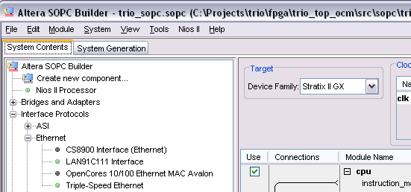
Figure 1 OpenCores MAC component location in SOPC Builder

Double-click on the component to add it to your system.

Configuring the MACs options
Adding the MAC to your system will bring of the Add component dialog box for your instance of the component as shown in Figure 2.

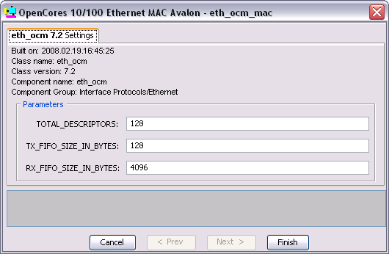
Figure 2 Configuring MAC options.

The explanation of the configuration parameters are explained below:
- TOTAL_DESCRIPTORS – The original implementation of the OpenCores MAC contains 128 descriptors. The new module have provides you with the option of creating less if you wish to do so to save on memory and logic usage. No matter what you put in here, the code will internally limit it to 128 maximum and 2 minimum descriptors.Also, the value will be rounded up to the next power of 2.
- TX_FIFO_SIZE_IN_BYTES – This controls the size of the transmit FIFO. The purpose of the transmit FIFO is to prevent starving the MAC of data when it is transmitting data. An extremely large value doesn’t make too much sense here. You may enter whatever value you like but the code will internally limit the FIFO to a minimum of 64 bytes. Also, any value you enter will be rounded up to the next power of 2.
- RX_FIFO_SIZE_INBYTES – This controls the size of the receive FIFO. The receive FIFO provides two major functions. It allows the Avalon bus to provide backpressure on the DMA controller without resulting in a loss of data. It also acts as a data buffer to allow the host processor time to process incoming frames. If the host processor does not process frames fast enough, this buffer fills up and frames begin to be discarded. You can choose whatever size you like but the code will internally limit the FIFO to a minimum of 128 bytes. Also, any value you enter will be rounded up to the next power of 2.

Connecting the MAC to the Avalon BUS
The Avalon OpenCores MAC contains one Avalon slave port (for host processor control) and two Avalon master ports (one for transmit DMA and one for receive DMA). Figure 3 shows an example implementation of the MAC connected to a NIOSII processor and DDR2 memory.

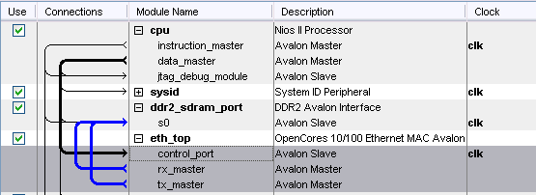
Figure 3 Connecting the MAC to the Avalon BUS.

Classic vs. Current Component
The Avalon OpenCores MAC is designed to be used in conjunction with SOPC Builder version 8.0. The method for creating custom components in 8.0 and future releases of SOPC builder is to create a TCL script which describes the component. The old method (now referred to as the classic method) involves a class.ptf file for the component.
The Avalon OpenCores MAC provides both a TCL script and a class.ptf file. You can only use one or the other. By default, this version of the component uses the TCL script method. The one problem with using this method is that in 8.0, Altera provided no way for the TCL script to add WIZARD_SCRIPT_ARGUMENTS to the final generated PTF file which describes the system. This is not necessarily a problem other than the “Is_Ethernet_Mac = “1”” argument is needed in order for the NIOSII IDE to determine that the component is in fact an Ethernet MAC.
As such, the IDE will not detect the component as a MAC and will not allow you to enable the InterNiche Stack for your software project. Once you generate your system, you will have to manually edit the PTF file for your system and add Is_Ethernet_Mac = “1” to the WIZARD_SCRIPT_ARGUMENTS for your instance of the Ethernet MAC.
If you want to use the classic method, rename “eth_ocm_hw.tcl” to “eth_ocm_hw.tcl.unsued”. SOPC builder will no longer detect the TCL script and will use the classic component.

Compiling the project in Quartus
The new approach to SOPC builder custom components is to reference the component as a user library within Quartus. This method avoids the unnecessary copying of all the source code files for the component into your local project directory. You must add the path to the OpenCores MAC component to your project’s list of user libraries for the project to compile properly. Failure to do so will result in compile time error messages stating that certain design entities cannot be found.
Figure 4 shows the eth_ocm component added as a user library for a project.

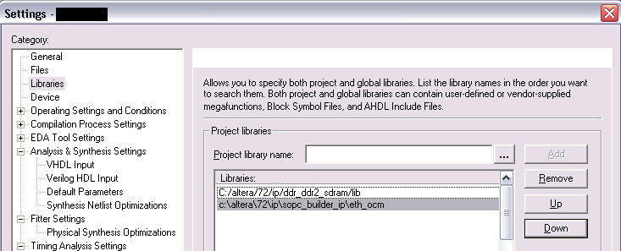
Figure 4 Adding OpenCores MAC component as a user library in Quartus.

Design Changes
This section describes the changes made to the OpenCores MAC in order to implement the Avalon interface.

Design Files

Removed Files
The following files were removed from the original implementation:
- eth_fifo.v
- eth_spram_256x32.v
- eth_wishbone.v
- xilinx_dist_ram_16x32.v

Modified Files
- eth_top.v – Renamed to eth_ocm.v (our implementation had an instance called eth_top). Modified top level port list for new Avalon interface. Removed byte select logic on control port. Changed module to instantiate eth_avalon in place of eth_wishbone.
- eth_registers.v – Modified to remove byte select logic which is unused in the implementation.

Added Files
- eth_avalon.v – Replaces eth_wishbone.v. Encapsulates descriptor interface and TX and RX DMA controllers
- eth_avalon_bd_ram.v – Implements descriptor ram. This module implements an Altera altsyncram component.
- eth_avalon_dma_fifo.v – Implements dual-clock FIFOs used in both the TX and RX DMA controllers. This module implements an Altera dcfifo component.
- eth_avalon_functions.v – Implments various constant functions used at compile time.
- eth_avalon_rxdma.v – Implements the receive DMA interface.
- eth_avalon_txdma.v – Implements the transmit DMA interface.
- eth_dc_reg.v – Implements a handshaking scheme for passing a signal across two clock domains.

Behavioral changes
In the original wishbone implementation, an interrupt would be generated on the Busy_IRQ line if a frame was received but there was no receive descriptor ready to receive it. The Avalon implementation is slightly different. In the Avalon implementation, a receive FIFO exists between the MAC core and the DMA interface. Thus there exists the potential for many entire frames to be buffered in the FIFO waiting for a receive descriptor to be available.
In the Avalon implementation, the Busy IRQ is asserted if a new frame is received and the receive FIFO is full. If the FIFO becomes full while receiving a frame that frame is truncated and the OR (overrun) bit is set in the descriptor when the DMA transfer is complete.

Software Driver for InterNiche TCP/IP Stack
This section describes the provided software driver for the OpenCores MAC that is designed to operate in conjuction with Altera’s implementation of the InterNiche TCP/IP stack. This driver has been tested with both the UCOSII and superloop versions of the InterNiche Stack.

Software Files
The software driver is made up of the following files:
- inc/eth_ocm_regs.h – Contains the register mappings for the OpenCores MAC with corresponding IOWR and IORD macros for accessing those registers.
- HAL/inc/eth_ocm.h – Not much. Contains some default macros for the OpenCores MAC. Also defines the INSTANCE and INIT macros to nothing in the event that the Altera InterNiche Stack is not being used. These macros are called when the MAC is initialized in alt_sys_init.
- HAL/inc/eth_ocm_desc.h – Provides macros for accesing the MAC’s descriptors and also provides the TX and RX descriptor bit mappings.
- HAL/inc/eth_ocm_phy.h – Provides macros and function prototypes for accessing the external PHY chip via the MAC’s MDIO interface.
- HAL/inc/ins_eth_ocm.h – Main header file for OpenCores MAC InterNiche software driver. Contains several structs used during runtime, function prototypes, initialization macros and configuration option macros.
- HAL/src/eth_ocm_phy.c – Contains functions for accessing the external PHY via the MAC’s MDIO interface. Also provides a default PHY initialization routine.
- HAL/src/ins_eth_ocm.c – This files implements the OpenCores MAC InterNiche driver. Provides all functions used by the InterNiche stack to perform read and write transfers, sets up interrupt handlers etc.
- HAL/src/component.mk – This is the makefile for the component. It lists the above source code files to be compiled in with the project. NOTE – This file also defines the ALTERA_TRIPLE_SPEED_MAC macro when the project is compiled. We do this because this forces Altera’s implementation of the InterNiche Stack to use uncached packet allocation routines. This driver makes use of the fact that packets received from the InterNiche stack are not cached and thereby avoids unnecessary copying or flushing of the data cache.
- eth_ocm_sw.tcl – TCL script which describes the software component when used with Altera’s BSP flow. This files is presently unused by the NIOSII IDE but will likely be used in place of the component.mk file in future versions of the IDE.

Software Driver Options
There are certain macros defined (or not defined) in the software driver which you can change to tweak the driver for your performance needs. These are described below.

- ETH_OCM_DBG_LVL – ins_eth_ocm.h – This macro defines the level of debugging print statements the driver will print to stdout. A lower number means less information. You can look though the code to see what gets printed for each level. Setting this level too high will impact the performance of your system as printing to stdout is a time consuming process. Also, Altera’s default implementation of their JTAG UART will cause the system to hang indefinitely if too much data is printed to it without being read. Obviously you can set macro to a higher value while you are debugging a problem but during regular runtime it should really be set no higher than one.

- ETH_OCM_SYNC_TX – ins_eth_ocm.h – This macro is not defined by default. Defining this macro forces the driver to use synchronous transmit operations. Doing so means the driver will block until a frame is sent or until a timeout is reached. The alternative to this is of course asynchronous transfers (default). Using asynchronous transmits, the transfer is set up and an interrupt is generated when the transfer completes.
The implementation that you choose may depend on your design. On the one hand, with synchronous transfers, the processor can do no other work until the frame is transmitted. On the other hand, with synchronous transfers the processor will spend more time servicing interrupts. You might with to try both options with your design to see which gives the better performance.

- ETH_OCM_TX_DESC_COUNT – ins_eth_ocm.h – This macro defines the number of descriptors you wish to use for transmit operations. This defaults to 1. NOTE – if you use synchronous transmit operations (as defined by ETH_OCM_SYNC_TX) there is absolutely no reason to use more than 1 descriptor as the driver will only use one at a time anyway. Again, you’ll have to play with this number to see how it impacts performance in your design. Essentially the higher the number, the more transmit operations that can be taking place simultaneously.

- ETH_OCM_RX_DESC_COUNT – ins_eth_ocm.h – This macro defines the number of descriptors you wish to use for receive operations. This defaults to 1. The higher the number, the more receive frames the DMA controller can handle without waiting for the processor to reload the descriptors. You’ll have to play with this number to see how it impacts your performance.

NOTE – It is important that you set this number accordingly with the number of NUMBIGBUFS defined in the InterNiche Stack’s “ipport.h” file. One of the first things the OpenCores MAC driver will do is request this number of packets from the InterNiche stack to be used for receive frames. As such you should give some cushion between the number of RX descriptors you use and the number of NUMBIGBUFS available to the stack as it will want to use some of those buffers for other operations.

- ETH_OCM_USE_INTERNAL_PHY_INIT – eth_ocm_phy.h – This macro is detailed below. Used to determine whether to use the provided PHY initialization function or to use one provided externally in user code.

Interfacing with your PHY chip
Every PHY chip requires a different initialization sequence. The OpenCores MAC driver requires only one piece of knowledge from the PHY; whether the PHY is operating in FULL or HALF duplex. This information is needed when the driver is initialized. The driver expects a function called “eth_ocm_phy_init()” to be defined externally. This function is intended to be used to perform any PHY specific initialization and return the duplex state of the PHY. This function is detailed below:

/**
* Performs PHY initialization and determines link duplex.
* This is fully vendor specific depending on the PHY you are using.
*
* @param dev Pointer to eth_ocm_dev struct which contains needed base address
* @return 1 if Link is established in Full duplex.
* 0 if Link is established in Half duplex.
*/
int eth_ocm_phy_init(eth_ocm_dev *dev);

A default implementation of the “eth_ocm_phy_init()” function is provided in “eth_ocm_phy.c”. At the time of this writing, the eth_ocm_phy_init() function will successfully detect and initializes four different PHY chips:
- The Intel LXT972A 10/100 Ethernet PHY.
- The Marvell 88E1111 10/100/1000 Ethernet PHY (used on the StratixIIGX Audio/Video development board).
- The National Semiconductor DP83848C 10/100 PHY (used on the Cyclone III embedded development kit).
- The Vitesse 8641 10/100/1000 Ethernet PHY.

You may use this existing function if you wish and add any code to accommodate your PHY. However, it is recommended that you use this function as a template and create your own implementation of “eth_ocm_phy_init” specifically for your design. This will avoid compiling in the bulky init function and allow you to compile in only code that you need.
In order to disable the provided “eth_ocm_phy_init()” function, simply comment out the ETH_OCM_USE_INTERNAL_PHY_INIT macro found in “eth_ocm_phy.h”. You can then provide your own implementation of the function in user code.

Test Platforms
This component is of course provided without any guarantee. At the time of this writing the implementor has tested the component under three hardware platforms:
1 – An Altera CycloneII EP2C35 with DDR2 memory.
2 – An Altera StratixIIGX EP2SGX90 with Synchronous SRAM memory.
3 – An Altera CycloneIII EP3C25 with Synchronous SRAM memory.
4 – An Altera StratixIIGX EP2SGX130 with Asynchronous SRAM memory.

In addition, the software driver has been tested on the above platforms using both the UCOSII and superloop versions of the InterNiche stack.

Revision History
July 3, 2008 – Updated component and document for version 8.0 of SOPC builder. This affects section entitled “Installing the source files. “. Please read this section in order to correctly instantiate the component in SOPC Builder.
July 3, 2008 – Updated document to include one added test platform and PHY.
July 3, 2008 – A bug was repaired in the “eth_avalon_txdma.v” source file which contributed to the last byte of data being dropped on some packets.
August 12, 2008 – “eth_avalon_txdma.v” was modified to prevent FIFO overflows when the avalon bus has a large amount of read latency. This should have been done originally but it was not.

